Martin Ambros, Brett Daniels, Sean Rettig
2015-04-09
ROB 421

Group Design Concept Proposal

Design

In order to keep our design simple, we will be using a launching mechanism similar to a baseball pitcher, allowing us to just have a motor that spins constantly at a steady speed. Ping pong balls will drop from a vertical tube-shaped hopper and slide down a ramp into a large vertical wheel that is suspended just above the ramp. As each ball squeezes between the ramp and the wheel, it is accelerated quickly and launched off of another ramp and (hopefully) into an enemy cup. The speed of the wheel is adjusted to modify the distance of each shot, while the entire assembly is mounted on a scanner carriage that should allow it to move from side to side. Balls are released one-by-one from the hopper by a rotating horizontal disc with a ping-pong-ball-sized wedge cut from it, allowing the loading mechanism's motor to simply make one full revolution to release a ball. The entire robot will be controlled by just these three motors (loading motor, launching motor, and scanner motor). If time permits, we may also add a basic swatting arm that attaches to the base of the scanner (the part that does not move side to side) that swings back and forth above our team's cups using a fourth motor.

These motors will all likely be servos, as they should provide us with the power and control we need while also being plentiful. These will be connected to our external power source and microcontroller through H bridges, and the microcontroller will be connected directly to our robot's computer. We may also end up using a sensor to determine where the carriage is on the scanner base, but this is not necessary if we control the sideways motion of the robot remotely rather than automatically.

The robot's computer will provide the remote control computer with the feed from our front-mounted webcam via an Internet connection. The remote controller will then send commands to the robot indicating the game state. When it is our team's turn, we will be able to select which cup to aim for, and possibly perform adjustments to carriage location and motor speed as well (to compensate for wind, for example). Once a cup is selected, the robot takes over and uses computer vision to detect the apparent size of the cup, from which it can infer the cup's distance and therefore the proper speed to set the launch motor to. The robot will then release a ball and attempt a shot. If time permits, we would also like to be able to detect the launched ball and automatically compensate for any inaccuracies on the next shot, though this is not critical as we should be able to manually adjust shots from the remote control. During an enemy turn, the robot should use computer vision (and possibly audio) to detect if an enemy ping pong ball has bounced, at which point it would activate the swatting arm. If time permits, we would like to program the robot to detect the speed and trajectory of the ball so it can time its swats precisely, but if this is determined to be infeasible, we should be able to manually adjust the “reaction time” of the robot based on how the enemy robot is shooting.

Goals

- High priority:
  - Robot shoots balls in a controllable and predictable manner
  - Loading mechanism reliably loads one ball at a time
  - Remote control can receive webcam feed and send commands to robot
- Medium priority:
  - Robot can detect cup locations/distances automatically and adjust its own position and motor speed accordingly
  - Robot can do basic detection of enemy bounce shots and activate the swatting arm
- Low priority:
  - Robot can track its own shots to automatically compensate for inaccuracies
  - Robot can track enemy bounce shots and time its swats to hit reliably

Sketch

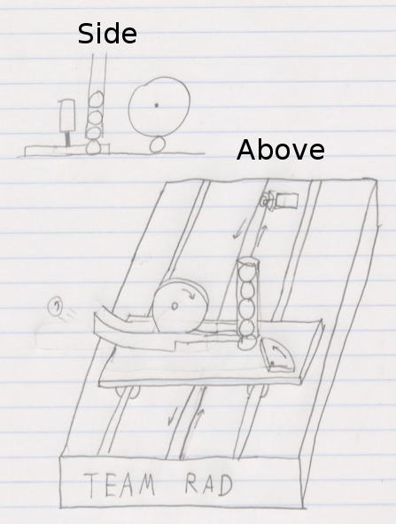
Block Diagram

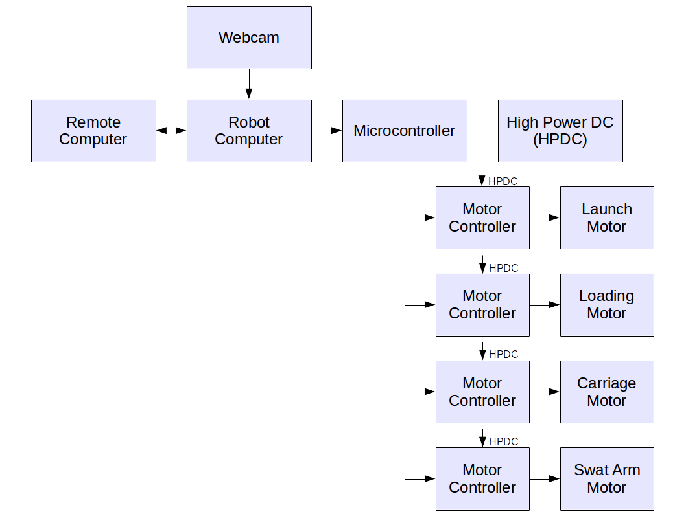

Flowchart of Functions

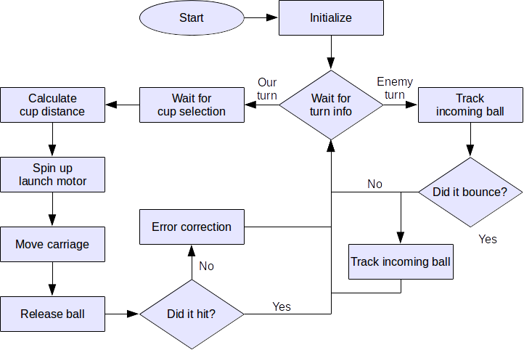
Team Responsibilities

Brett, our mechanical engineer, will focus on designing and building the physical structure of the robot, ensuring all pieces can handle the wear and stress placed on them while still allowing the robot to load, aim, and launch its shots reliably.

Martin, our electrical engineer, will focus on researching, wiring, and programming our microcontroller, motor controllers, and motors, as well as handling all power requirements and other electrical issues. Martin will also assist Sean with the computer vision component of the robot.

Sean, our computer scientist, will focus on implementing the base robot logic, physics calculation, remote control, and computer vision cup/ball detection/tracking components required to run the robot on a high level.

Initial Plan of Action

We plan to focus on our goals in roughly the order presented. Since our robot's success hinges on our launching mechanism, our first goal is to prototype it to ensure that it will shoot reliably enough to be viable. This will allow us plenty of time to devise an alternate launching mechanism in case our original design is not feasible. We plan to have completed all of our high priority goals by midterm, and all of our medium priority goals by the end of the term. The low priority goals are optional components that would be helpful, but are ultimately not critical to the function of the robot and will only be implemented if time permits.

